**Lab Task 3**

**Task 1:**

Converting height from inches to centimeters and feets.

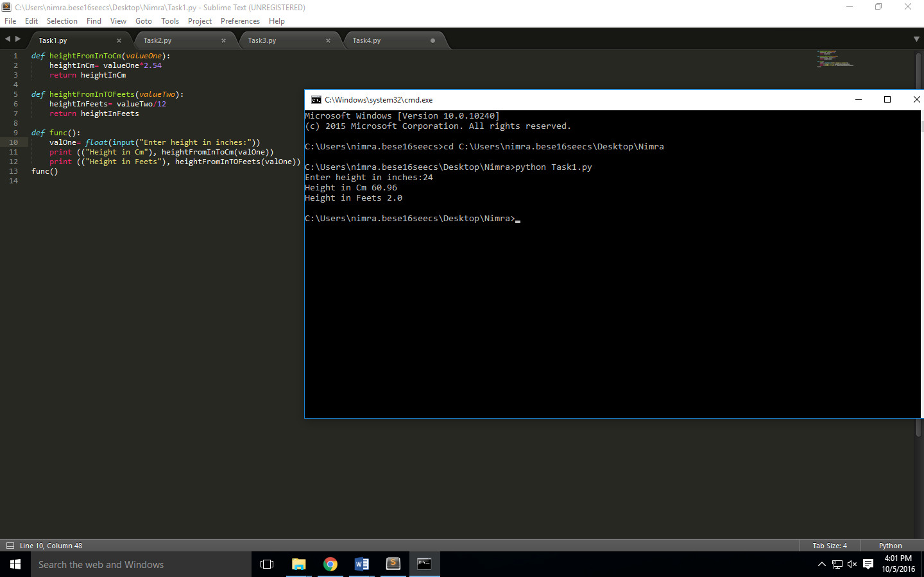

**Task2:**

Calculating volume of cylinder.

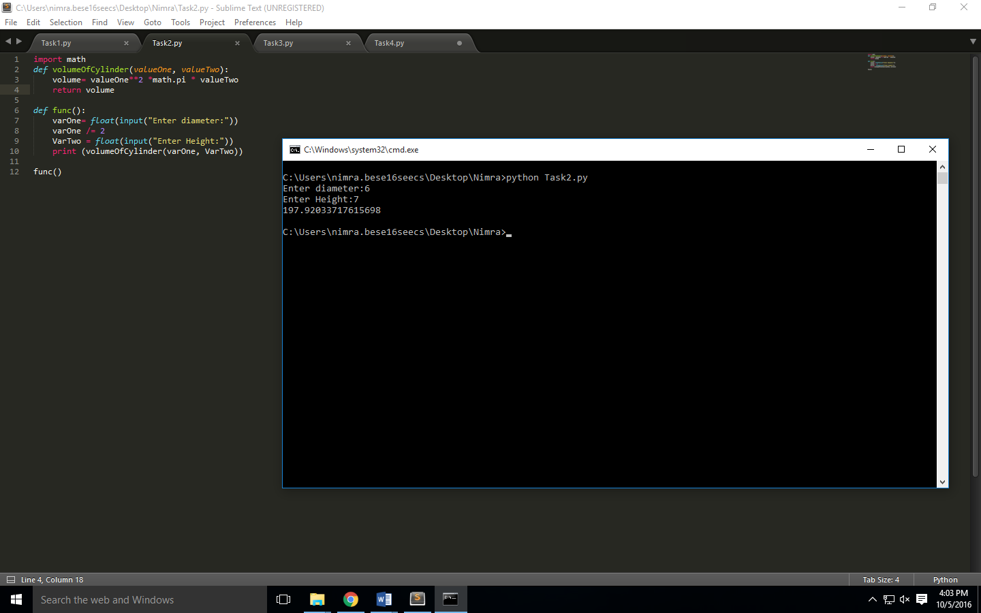

**Task 3:**

Math modules.

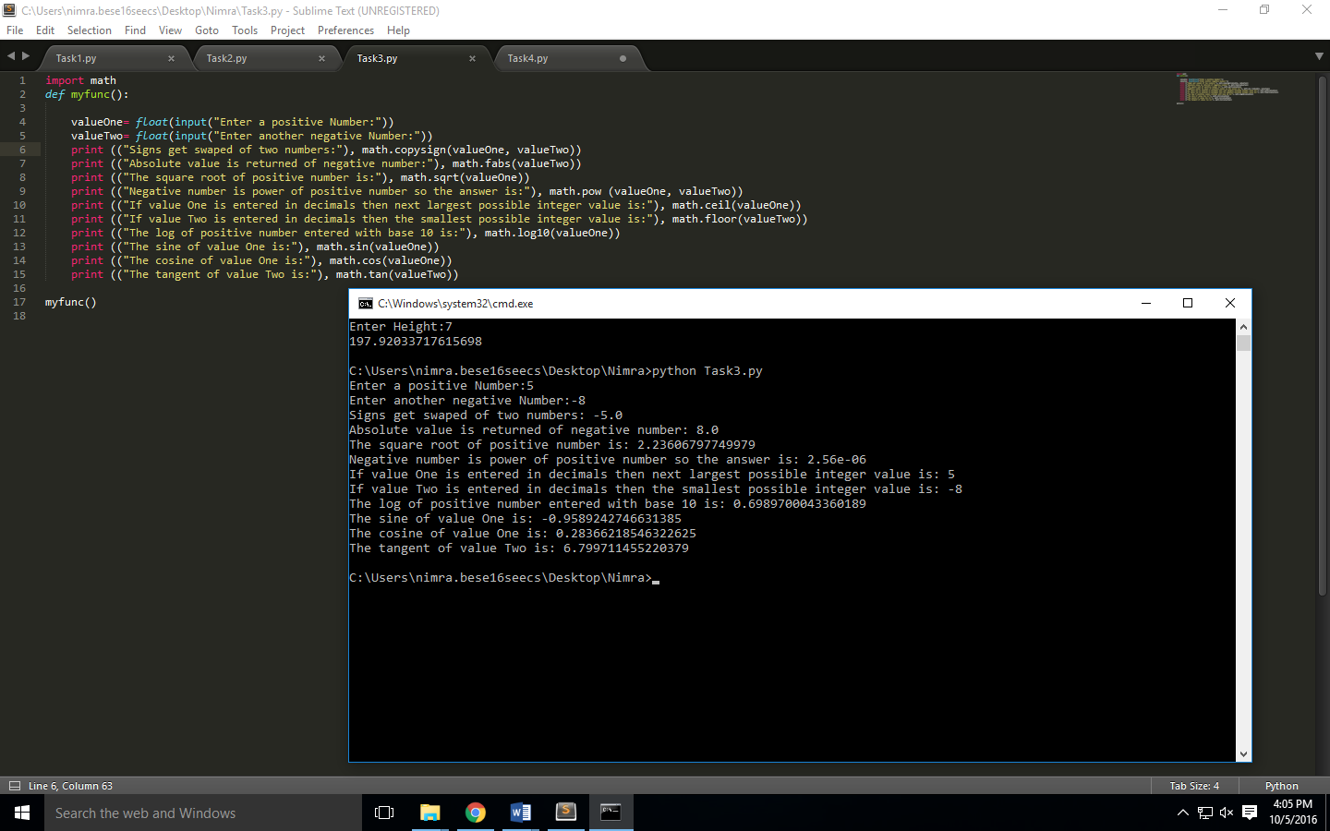

**Task 4:**

Usage of power.

